Un proyecto para la navidad:

You and a partner will create a presentation discussing the traditions and customs of the holiday season in a Spanish-speaking country. First, you will choose your partner and then we will choose countries by random draw. Your presentation may include, but is not limited to the following:

- Important Dates/when things are celebrated
- Historical background
- How it is celebrated
  - Activities
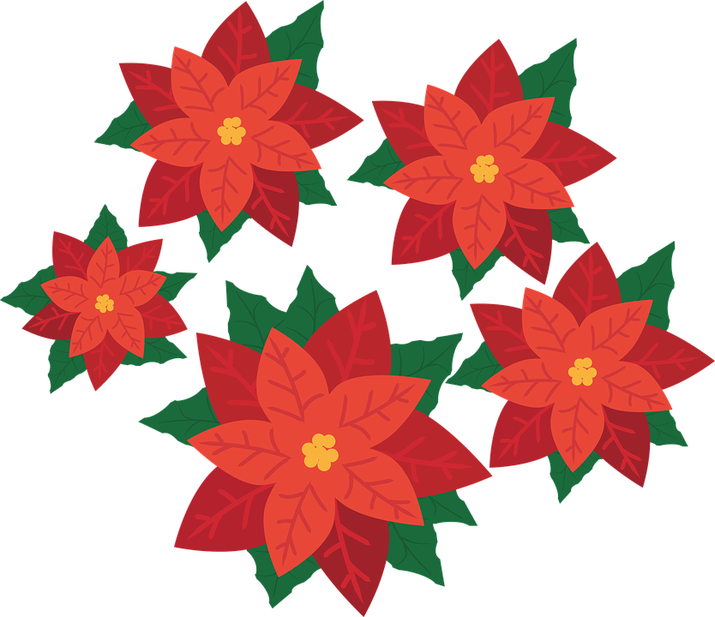
  - Decorations
  - Food
  - Music
  - Costumes
  - Parades/Parties
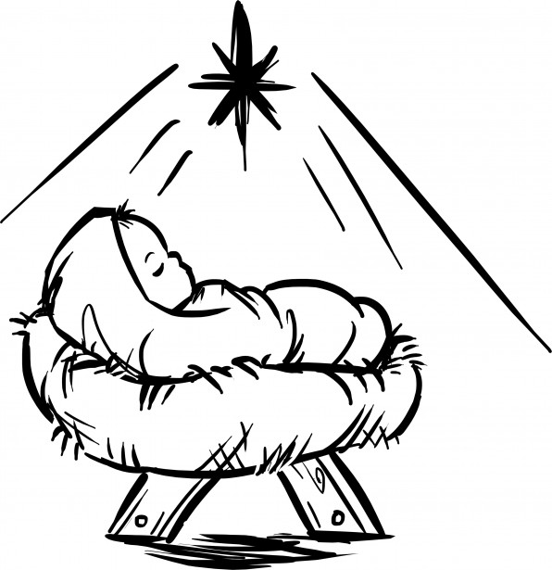
Presentation Requirements:

- Title Slide (5 points)
  - Name of country
  - Your names
  - Hour
  - County Flag and Map

- 10 slides of information (50 points)
  - Information presented in English, but must include Spanish vocabulary and explanations.

- Photos on each slide (10 points)

- Presentation to class (10 points)

Puntos Totales: 75
Spanish-speaking countries:

- Argentina
- Bolivia
- Chile
- Colombia
- Costa Rica
- Cuba
- Dominican Republic
- Ecuador
- Guatemala
- Honduras
- Mexico
- Nicaragua
- Panama
- Paraguay
- Peru
- Puerto Rico
- Spain
- Uruguay
- Venezuela

