Mi abuelita ya no está:
Nombre:
Fecha:
Hora:
Preguntas del cuento

- Who passed away?

- When did he/she pass away?

- What is the main character (Marita) doing that her Mother says is a good thing?

- What does her Mother say about abuelita on page 3?

- Why does this confuse Marita?

- Who did her Mom send her to go talk to?

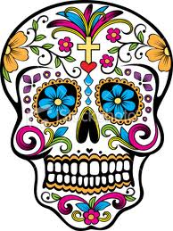
- Where does she live (describe the house)?
- What is the word that they use to describe her?

- What does this new character give to Marita when she arrives?

- What does is have on the top/front of it?

- What does the woman she visits say about their ancestors?

- What does she say about the spirits of loved ones (family and friends)?

- Why does she say that it is good to remember the deceased?

- What happens on November 2nd?

- What do they prepare/set up for their deceased loved ones?

- What does this do for the spirits?

- What do they make for their loved ones and what do they put on it?

- Why do they do this?

- What do they buy?

- What is the name of the special flower and incense they purchase?

- What do they have at night? Describe it.

- Why do they feel so happy?

- Where do they spend the night?

- What do they do there?

- What does doña Ruthilda give Marita before she leaves?

- Why does she give this to her?

- What is Marita’s mother doing when she gets home?

- What do they add to it?

- What does Marita know at the end of the story (about her grandmother)?

