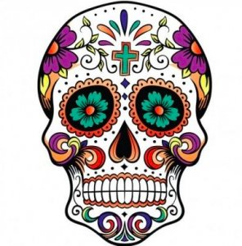
Webquest
El día de los muertos

- What is the Day of the Dead?

- Where is it celebrated?

- When is the Day of the Dead celebrated?

- What is the history behind the Day of the Dead? What is its origin?

- What are some of the traditions associated with the holiday?

- What is the purpose of families going to the cemetery? What do they do there?

- What is an “ofrenda” and what is its significance?

- What are the four elements of nature that are included on the altar? How are they represented on the altar?

- Whare are cempasuchíl? What color are the ones used to decorate the altar?

- What is pan de muerto?

- What other items are placed on the altar to decorate it?

- What are some of the other foods associated with the holiday? Describe them.

- Who are the “angelitos”?

- What items are placed on the altar for them?

- What is the Mexican view of death?

- Compare the Day of the Dead and Halloween. How are they similar? How are they different?
Día de los muertos
Halloween

